BPW Ontario Interim Board Report 2024-2025

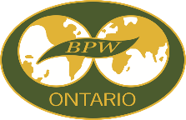

|  |  |
| --- | --- |
| **Name:** |  |
| **Position:** |  |
| **Committee Chair (if applicable):** |  |
| **Committee Members:** |  |
| How are you promoting the Sustainable Development Goals (SDG’s)? | |
| What are your key accomplishments, events, and activities? | |
| What challenges do you face? | |
| Represented BPW Ontario at: | |
| Suggestions/comments: | |

**INSTRUCTIONS:**

Create a separate report for each Board position held.

Include items planned or already completed for the year.

Submit in Word (.docx) format.

Email to [editor@bpwontario.com](mailto:editor@bpwontario.com) and [president@bpwontario.com](mailto:president@bpwontario.com)

Due Date: Saturday, October 26, 2024